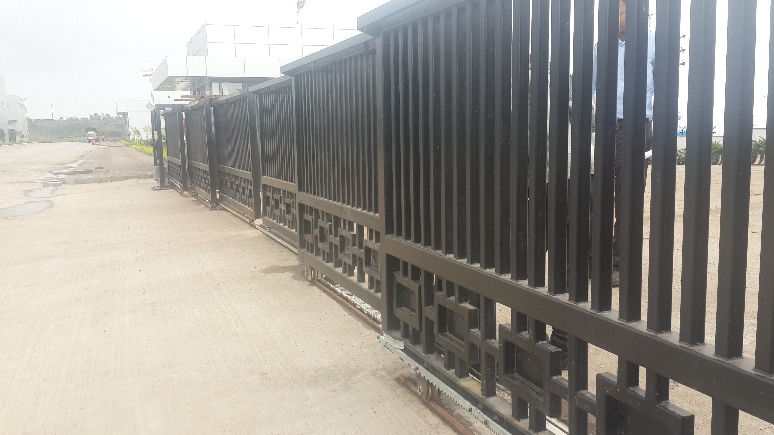
NIHVA make – Motorized Telescopic Sliding Gate
Door type | Motorized Sliding Gate
Clear Opening gate dimension | 8 Mtr (W) x 2 Mtr(H)
Opening Direction | Horizontal - from left to right or reverse
Mounting Location area | Inside area
Design Pattern | Standard Tubular Design Pattern
Outer Frame Tube Sizes | 80 x 80 x 3.2 mm
Internal Vertical Tube Sizes | 40 x 40 x 2 mm
Gap Between Tubes | 100 mm C/C
Bottom Rail on ground | dia 20 mm round bright bar with heavy duty support ISMB 100 X 50 Beams
Bottom Rollers | Heavy Duty Bottom Wheel With both side Bearings (chrome plated)
Full Height Column sizes | 100 x 100 x 3.2 mm
Guide Rollers supporter during Gate movement | Nylon Rollers with Bearings both side mounted on column for support smooth movement of gate
Painting | 2 Coats of EPOXY primer and 2 coats of Synthetic enamel paint
El motor | 100% imported European make Motor
Emergency Operation | Manual after turn the switch
Telescopic Mechanism | Inbuilt with Gate
Operating Switch | Push Button from inside
Safety | Photocells, Flashing Light
Metal Rack | zinc plated metal rack
Installation Checks | need to be check = space requirements + substructure + Mounting access + Access in the event of power cut
Civil work | Client scope – client need to grout the I beam in concrete to create track for sliding gate

